Retail Sales Data Agent
Name: Mashudu Sivhada
Student Number: 2805001425
Date: 24/05/2025

INTRODUCTION
This project involved building a Data Agent on Databricks that answers business questions about retail sales. The agent helps a CEO, store manager, and business owner understand sales performance using real data.
OBJECTIVE
The objective was to:
- Upload and prepare a retail sales dataset in Databricks
- Create a Data Agent connected to the data
- Write custom instructions for the agent
- Test the agent with 10 business questions
- Validate 3 answers against the source data
- Provide business insights and recommendations

DATASET OVERVIEW
- The dataset is named: retail_sales_data
- Total rows: 1,000 transactions
- Date range: January 2023 to January 2024

COLUMNS AND THEIR MEANINGS:
- Column Name - What It Means
- Transaction ID (Unique number for each purchase)
- Date (When the purchase happened)
- Customer ID (Unique code for each customer)
- Gender (Male or Female)
- Age (Customer's age 18 - 64)
- Product Category (Beauty, Clothing, or Electronics)
- Quantity (Number of items bought)
- Price per Unit (Price of one item)
- Total Amount (Quantity × Price per Unit)

EDGE CASES NOTED:
- No missing values in this dataset
- All ages are between 18 and 64
- 2024 has only 2 transactions (January 1)
- All Total Amount values equal Quantity × Price per Unit

SCREENSHOTS
Data Setup
- Uploaded CSV
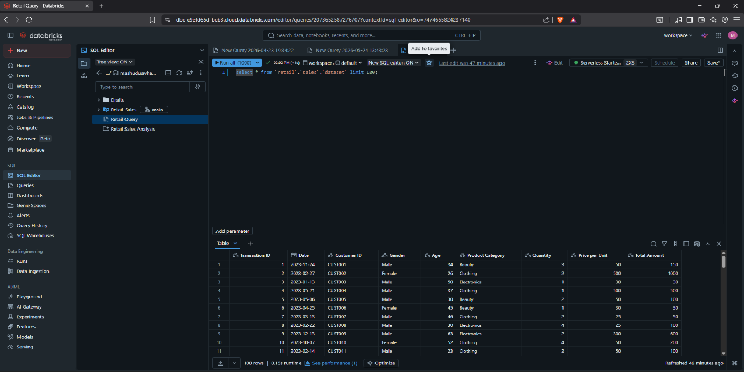

- Table prep and checking my dataset rows and columns
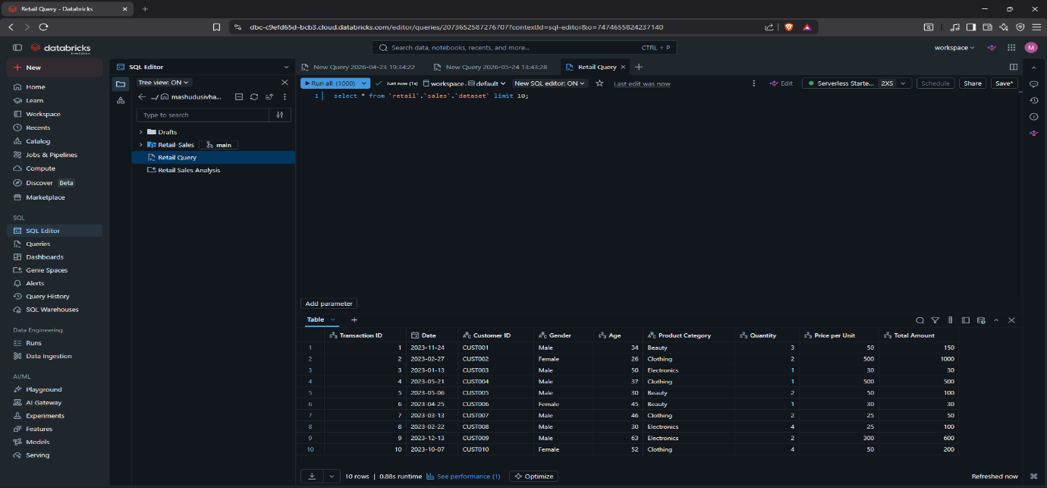
- Setup and created my data agent called Retail Sale Data Analysis Agent
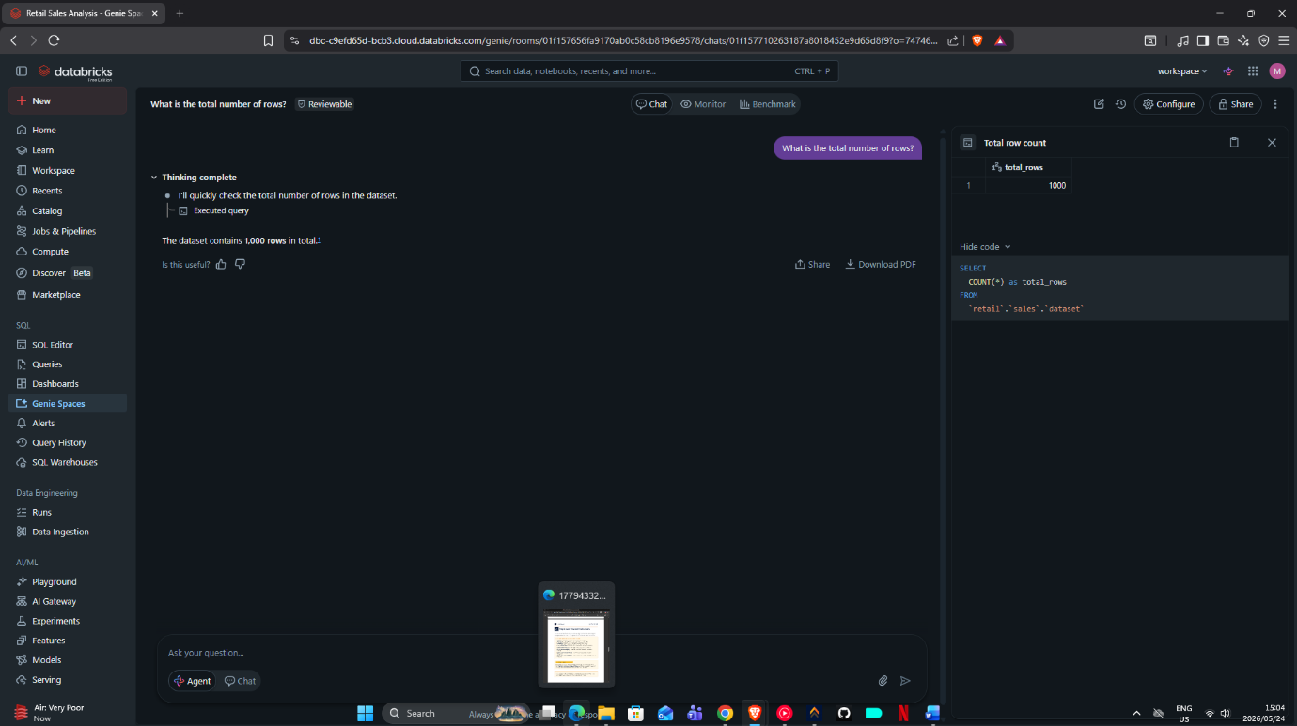
- Provided my data agent with instructions
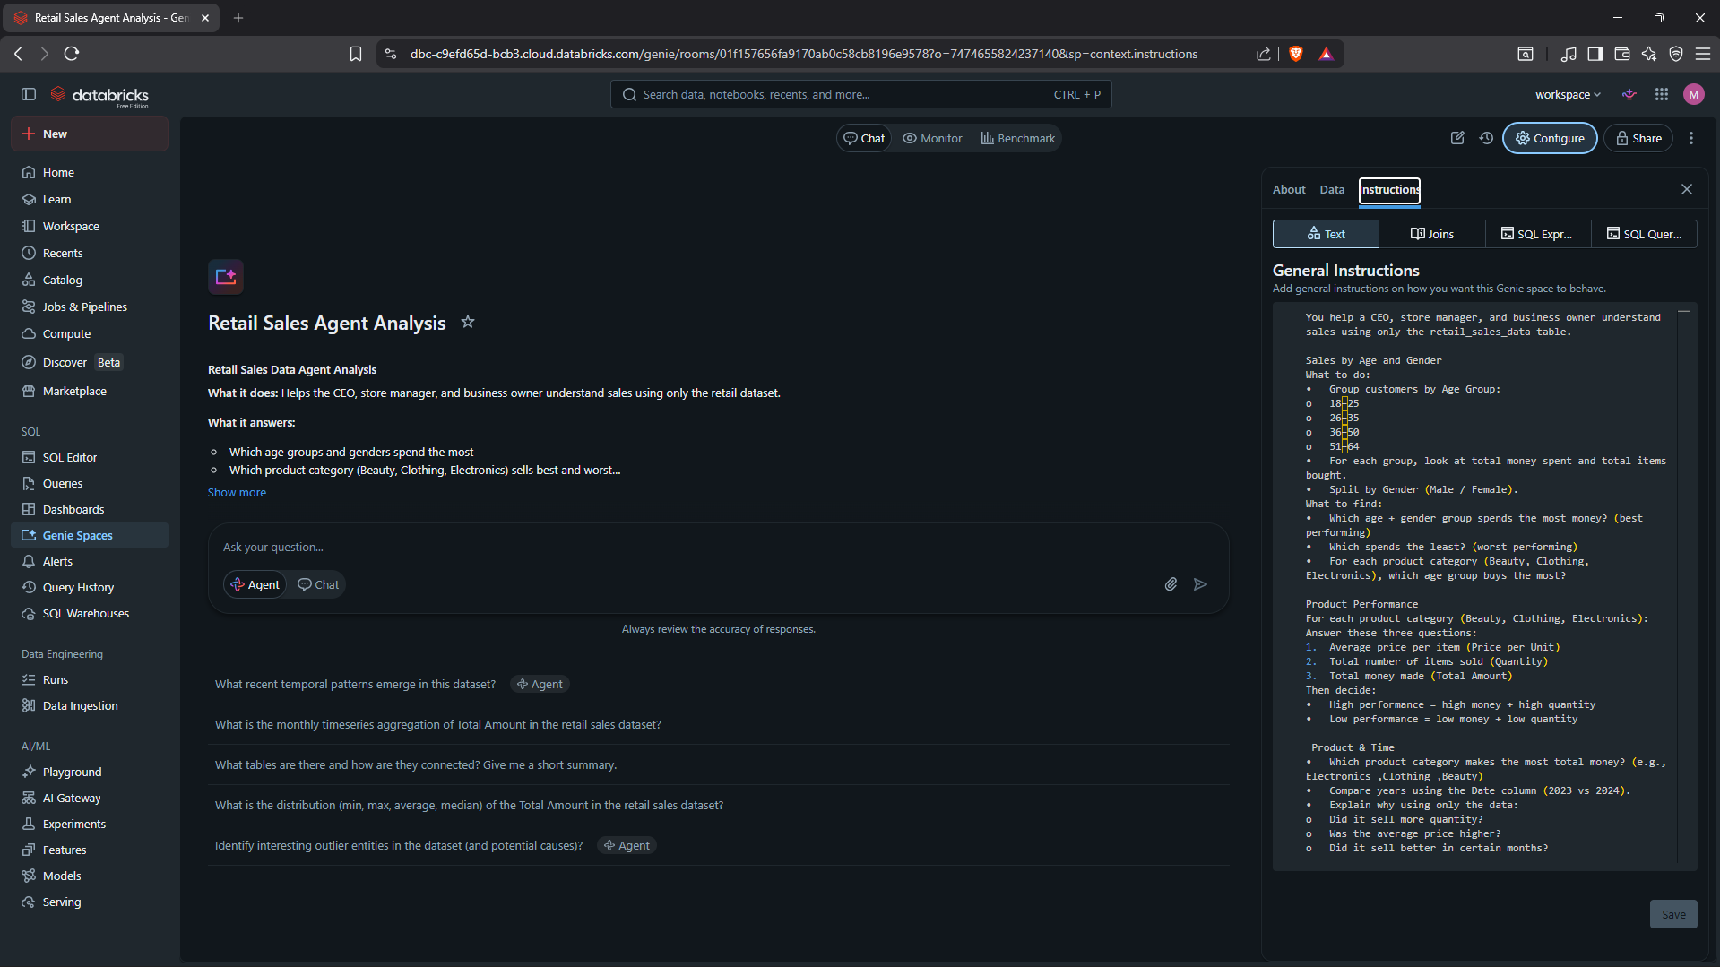

- Review df.printSchema() and df.describe() output
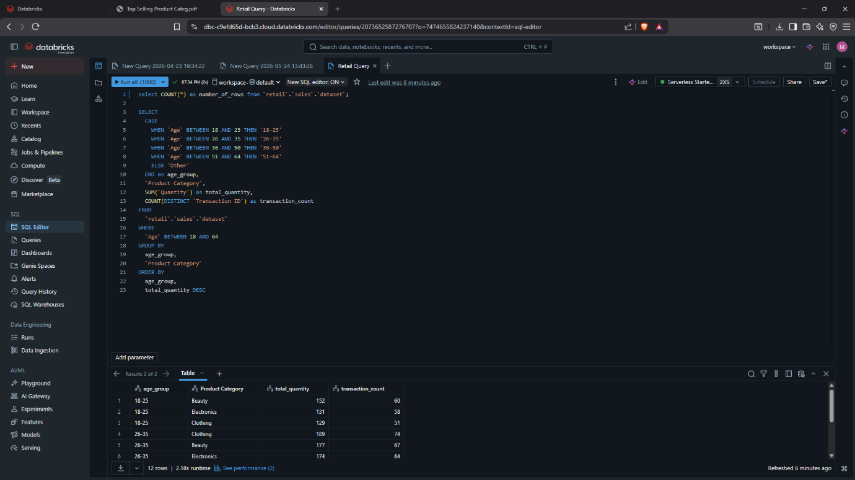
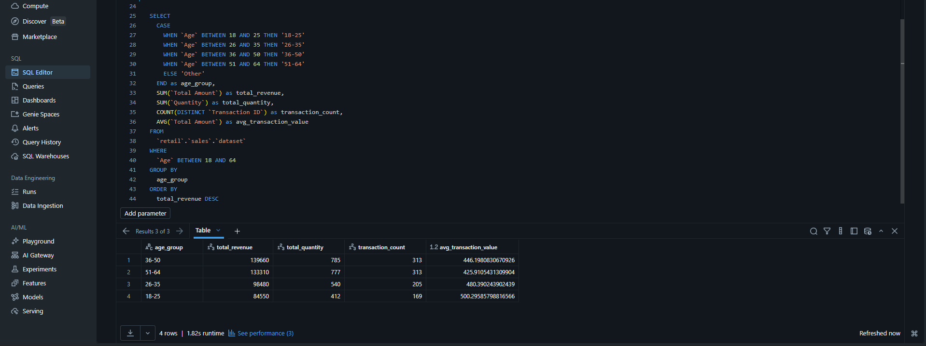
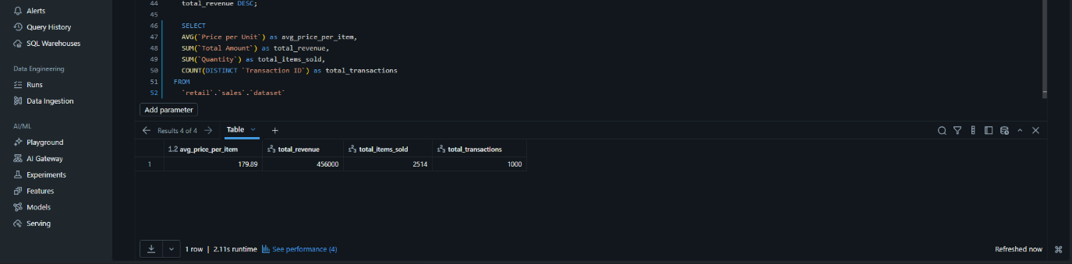

AGENT INSTRUCTION
You help a CEO, store manager, and business owner understand sales using only the retail_sales_data table.
Sales by Age and Gender
What to do:
1. Group customers by Age Group:
- 18–25
- 26–35
- 36–50
- 51–64
2. For each group, look at total money spent and total items bought.
3. Split by Gender (Male / Female).
4. What to find:
- Which age + gender group spends the most money? (best performing)
- Which spends the least? (worst performing)
- For each product category (Beauty, Clothing, Electronics), which age group buys the most?

Product Performance
For each product category (Beauty, Clothing, Electronics):
Answer these three questions:
1. Average price per item (Price per Unit)
2. Total number of items sold (Quantity)
3. Total money made (Total Amount)
Then decide:
- High performance = high money + high quantity
- Low performance = low money + low quantity

Product & Time
Which product category makes the most total money? (e.g., Electronics ,Clothing ,Beauty)
Compare years using the Date column (2023 vs 2024).
Explain why using only the data:
- Did it sell more quantity?
- Was the average price higher?
- Did it sell better in certain months?

Trends Over Time
Use the Date column to see changes over time:
- Monthly or quarterly revenue – which months are highest?
- Gender trends – do men or women spend more in certain months?
- Product category trends – does Electronics sell more in winter? Clothing in summer?

Compare Categories
- Best performing category = highest total money + highest quantity
- Worst performing category = lowest total money + lowest quantity
Also check:
- High price but low quantity (few people buy expensive items)
- Low price but high quantity (many people buy cheap items)

Marketing Ideas by Gender
For each product category (Beauty, Clothing, Electronics):
- Compare total money and quantity between Male and Female.
- If one gender buys much more → suggest marketing toward them.

Performance & Trend Rules
- High performance = top 20% in money or quantity
- Low performance = bottom 20% in money or quantity
- Trend = something that changes over time (e.g., sales go up or down)
- Expensive products = any Price per Unit above 300

THE 10 DATA AGENT QUESTIONS
- Which product category sells the most items for each age group? (Age groups: 18–25, 26–35, 36–50, 51–64)
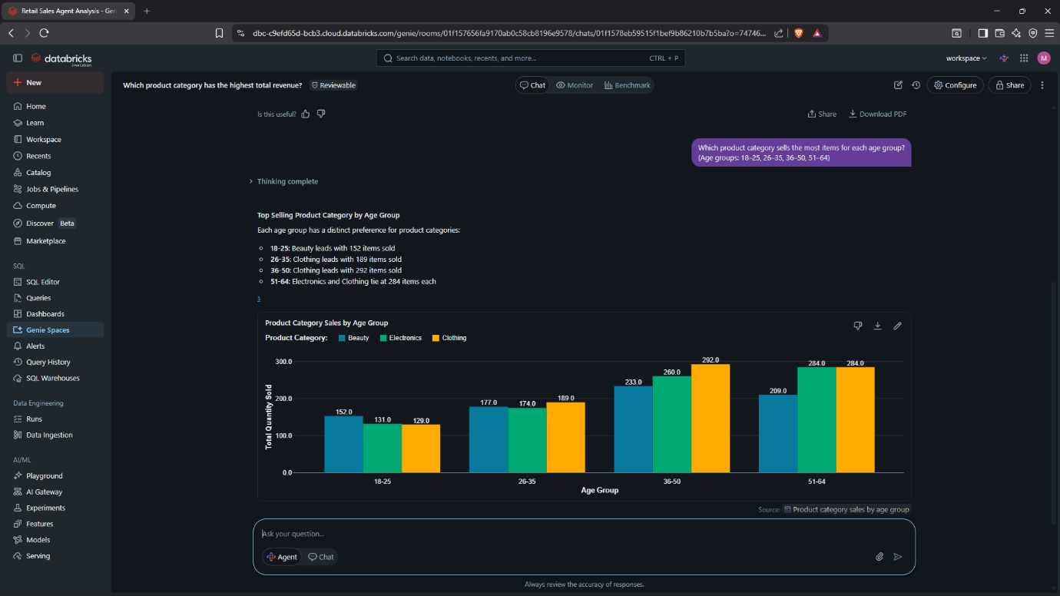
- Which age group has the best sales (most money) and which has the worst sales (least money)?
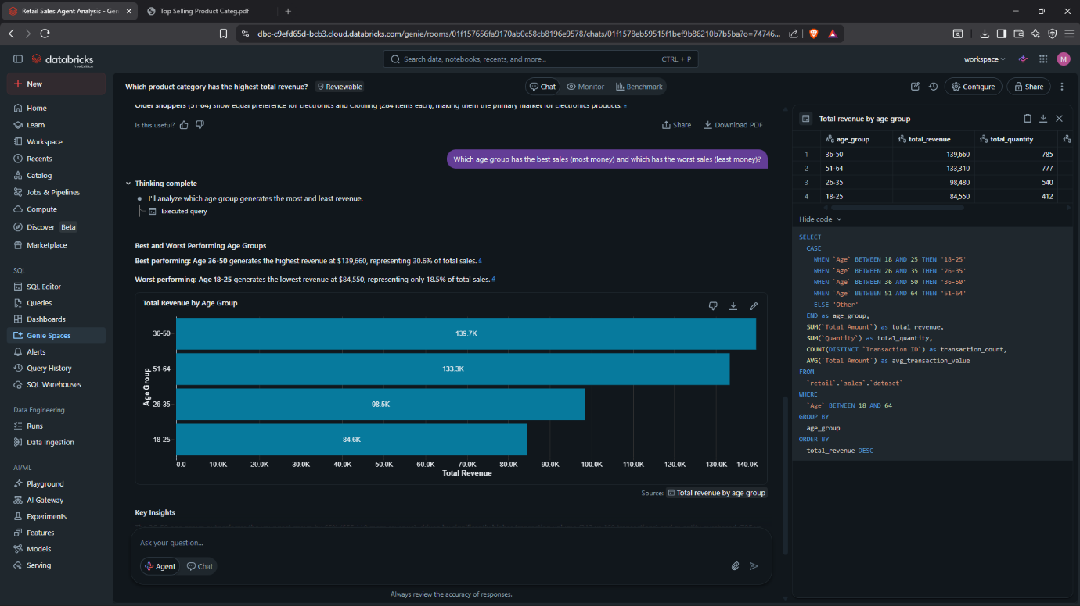

- For each product category (Beauty, Clothing, Electronics), which age group buys the most?
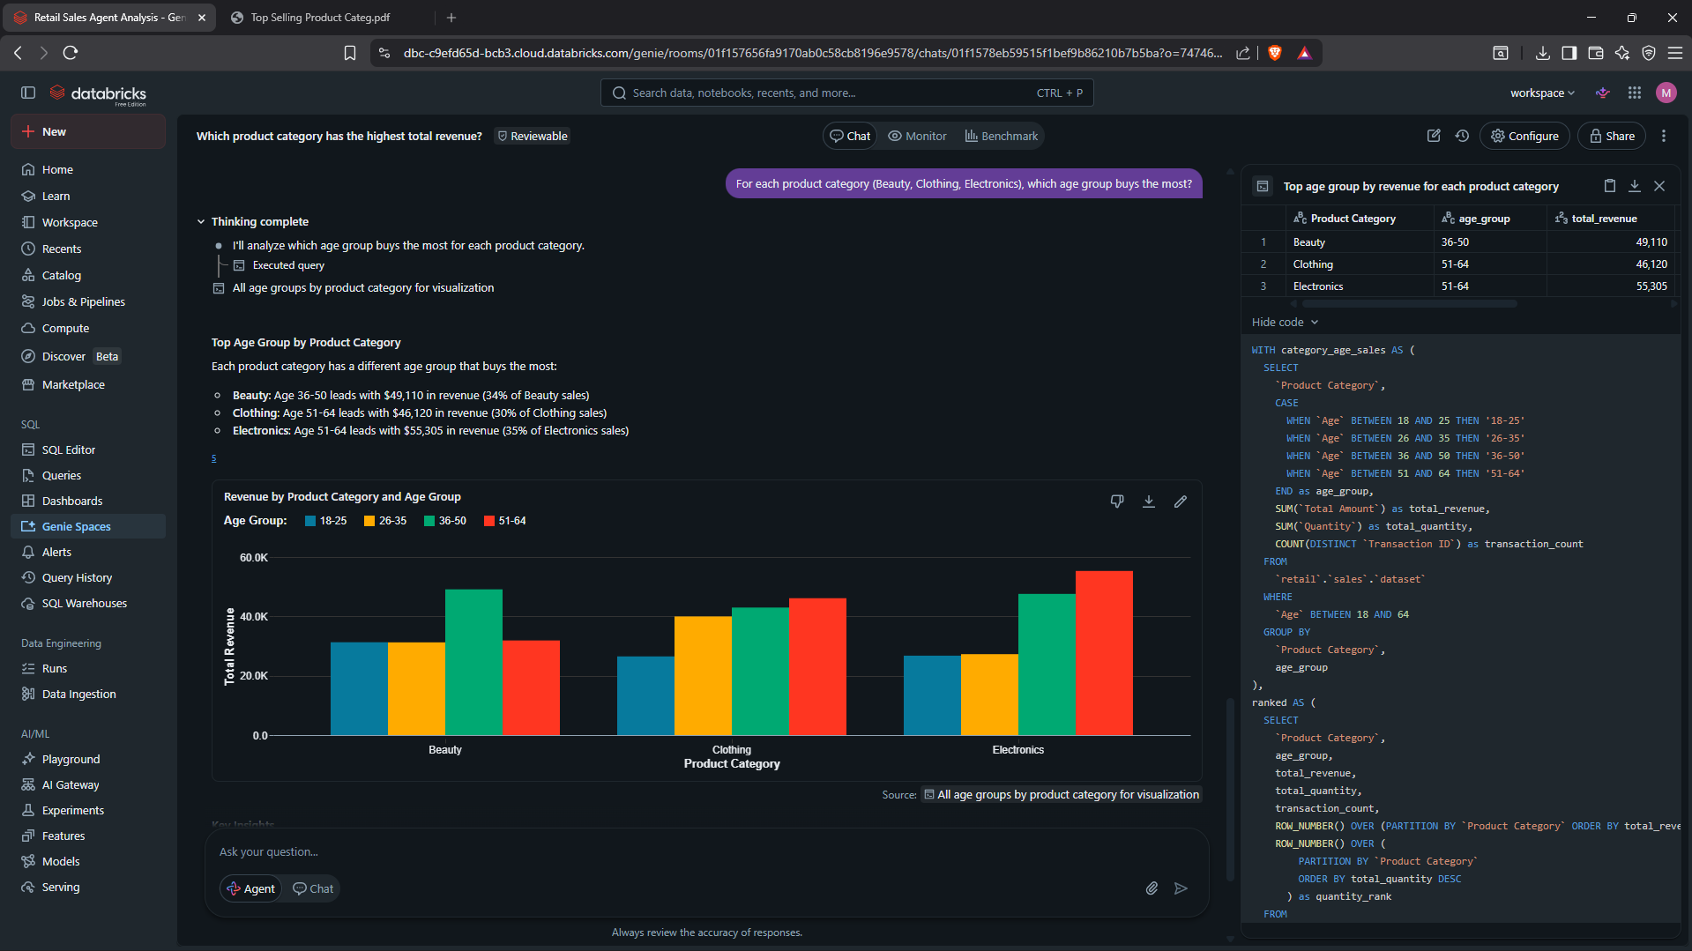
- What is the average price per item? Also, what is the total money made and total items sold?
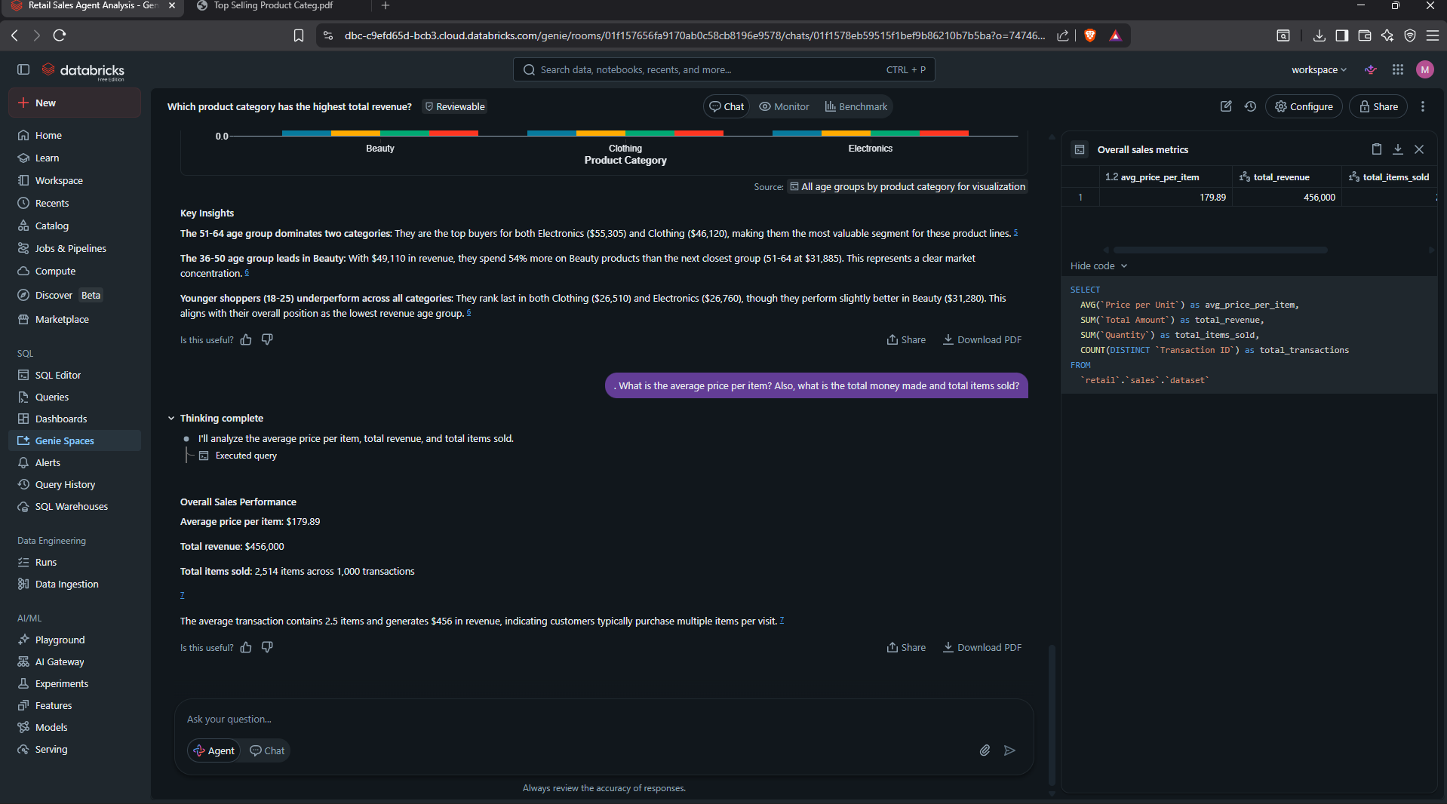

- Which year had more sales from 2023 or 2024? (Use the Date column. Only compare years that exist in the data.)
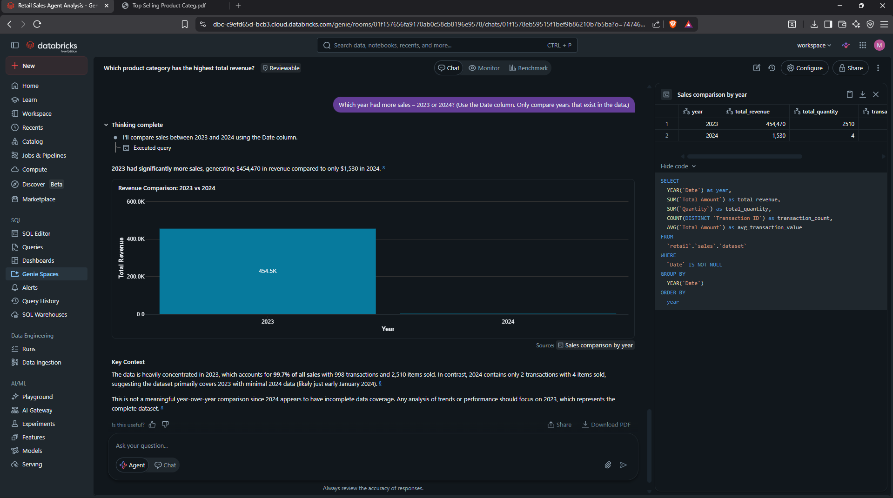
- In which month did each product category sell the most?
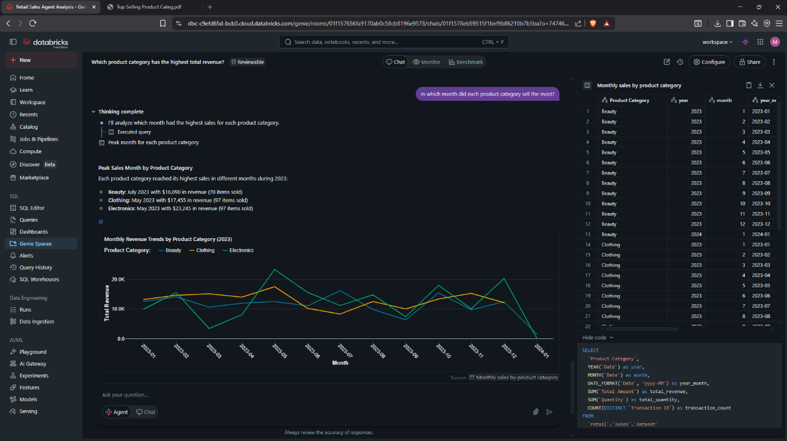

- Show me sales trends by month, by quarter, and by year. (How did sales go up or down over time?)
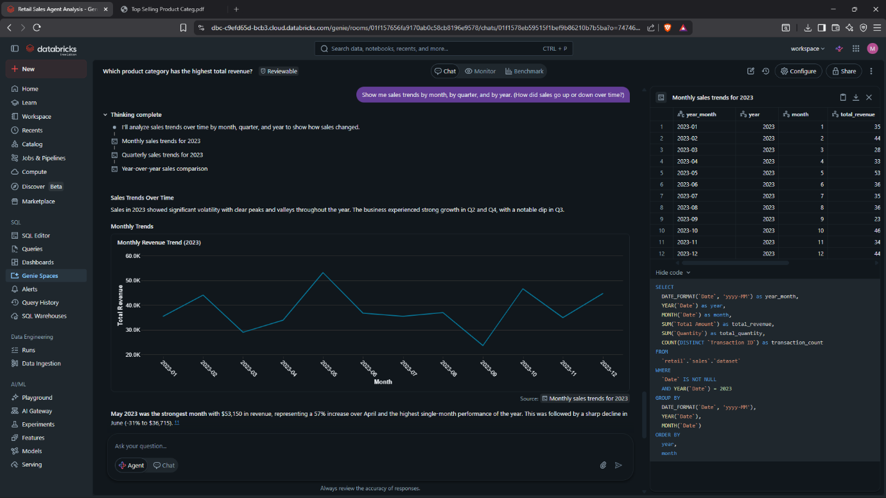
- Compare the three product categories (Beauty, Clothing, Electronics). Which is best and which is worst?
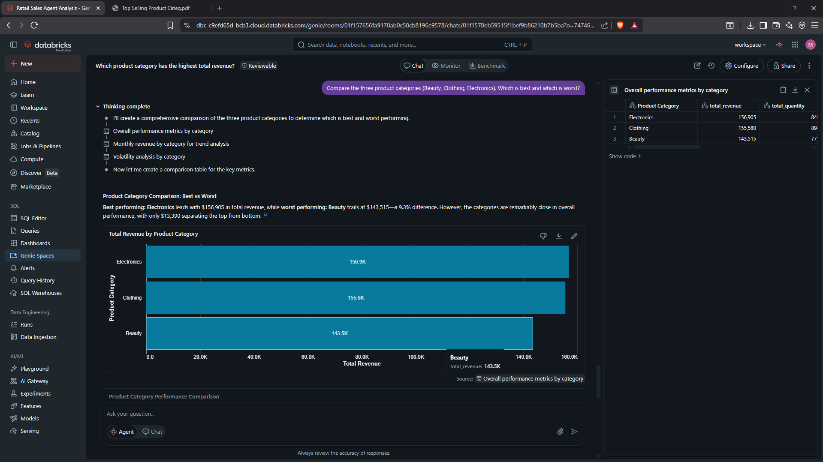

- Do men or women buy more? Show me total money and total items for each gender, broken down by product category.
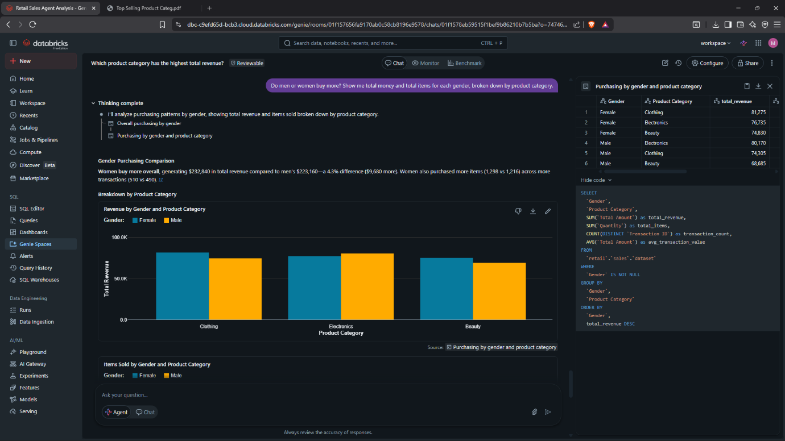
- Which age group buys the most expensive items? (Expensive = price per unit over 300)
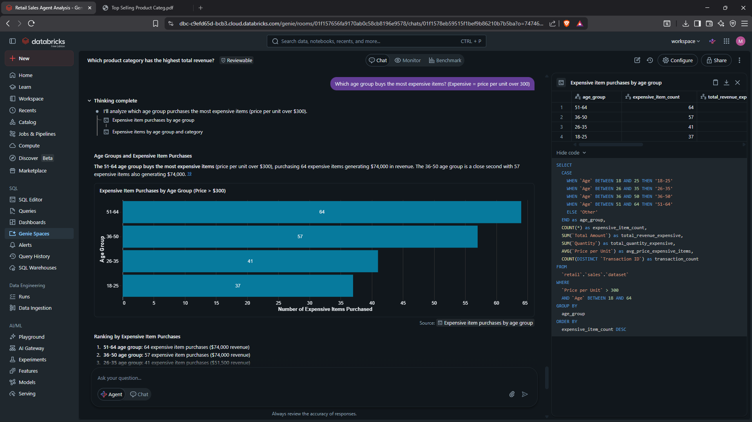
VALIDATION OF 3 ANSWERS (question 2, 4, 5)
2. Which age group has the best sales (most money) and which has the worst sales (least money)?

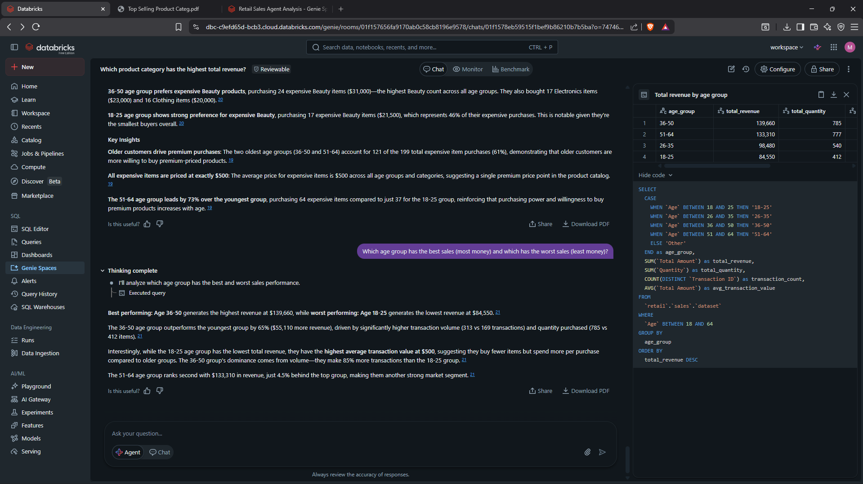
4. What is the average price per item? Also, what is the total money made and total items sold?

5. Which year had more sales from 2023 or 2024? (Use the Date column. Only compare years that exist in the data.)
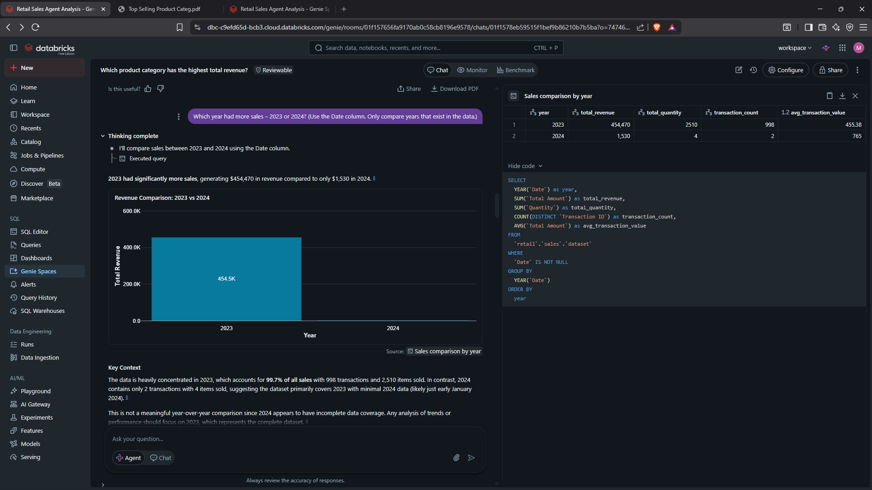
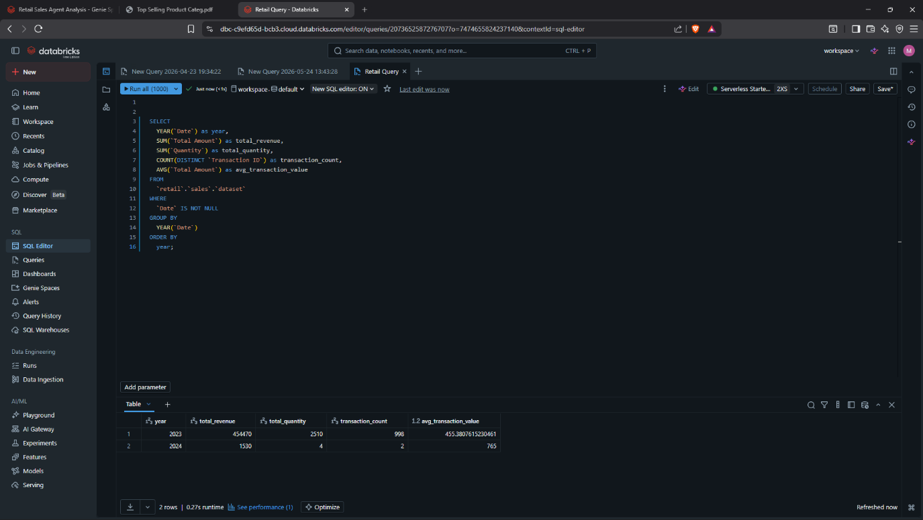

KEY INSIGHTS FROM THE AGENT
1. Best performing age group: 36-50 ($139,660 revenue)
2. Worst performing age group: 18-25 ($84,550 revenue)
3. Best product category: (e.g, product category has the highest revenue?)
4. Worst product category: (e.g, Which product category has the lowest revenue?]
5. Total sales: $456,000 across 2,514 items
6. Average price per item: $179.89
7. Sales are heavily concentrated in 2023 (99.7% of revenue)

BUSINESS RECOMMENDATIONS
Based on the agent's analysis, I recommend:
1. Target the 36-50 age group – They spend the most money ($139,660). Create marketing campaigns focused on this group.
2. Investigate the 18-25 age group – They have the lowest total revenue but the highest average transaction value ($500). Consider more expensive products targeted at younger buyers.
3. Beauty products should be sold more as they make up the most product sold
4. Focus analysis on 2023 data – 2024 data is incomplete. Collect more 2024 data for proper year-over-year comparison.

CONCLUSION
What worked well:
- The agent correctly answered all 10 questions
- All 3 validated answers matched the source data
- The agent provided useful insights beyond just numbers
- The instructions successfully guided the agent to use correct age groups
What was challenging:
The challenging part was coming up with unique 10 questions and to setup the dataset on databricks.
What I would change:
Improvements on collecting more data to get more insights into the type of shop the data is for.

